Abstract Template for Submission to PetroPhase2019

Speaking Author^{*1}, Second Author², and Corresponding Author^{†1}

¹Insitution 1 Department, Organization 1 Name, Location/Address
²Insitution 2 Department, Organization 2 Name, Location/Address

This abstract provides a template with the necessary format for submission to the PetroPhase2019 conference, which will be held in Kanazawa, Japan, on June 2-6, 2019. It has a similar format as that in PetroPhase2018 conference.¹ Note that the reference format follows ACS journal, in particular, Energy & Fuels. As usual, you must contain your entire submission in a single page of A4 paper. The font should be Times New Roman. The font size of title should be 16.The font size of author names, affiliation, and the main text should be 10.5. Images are allowed, but please include a figure caption. When you submit your abstract on the website, you will be guided to select one session among six: (1) Flow Assurance; (2) Upgrading and Fouling; (3) Petroleum Properties and Phase Behavior; (4) Petroleum Chemistry; (5) Unconventional Gas & Crudes; (6) Emulsions. It is our hope that you could enjoy high-quality oral and poster presentations from leading experts as well as emerging young talents in academia and industry in PetroPhase2019 conference. The participants can also feel a great taste of traditional Japan, such as Kenrokuren Garden (Figure 1) and fantastic foods.

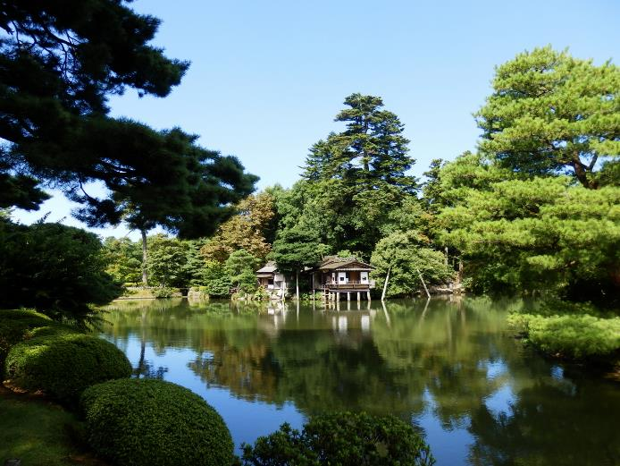

Figure 1. Kenrokuen Garden as one of the Three Great Gardens of Japan. The name of “Kenrokuen” stands for the six attributes of a perfect landscape: spaciousness, seclusion, artifice, antiquity, waterways, and panoramas.

- Hoepfner, M. P.; Deo, M.; Goual, L.; Adams, J.; Magda, J. J.; Venkatesan, R. Petrophase2018, 2018, Volume, Page.

